**Part I.**

1. 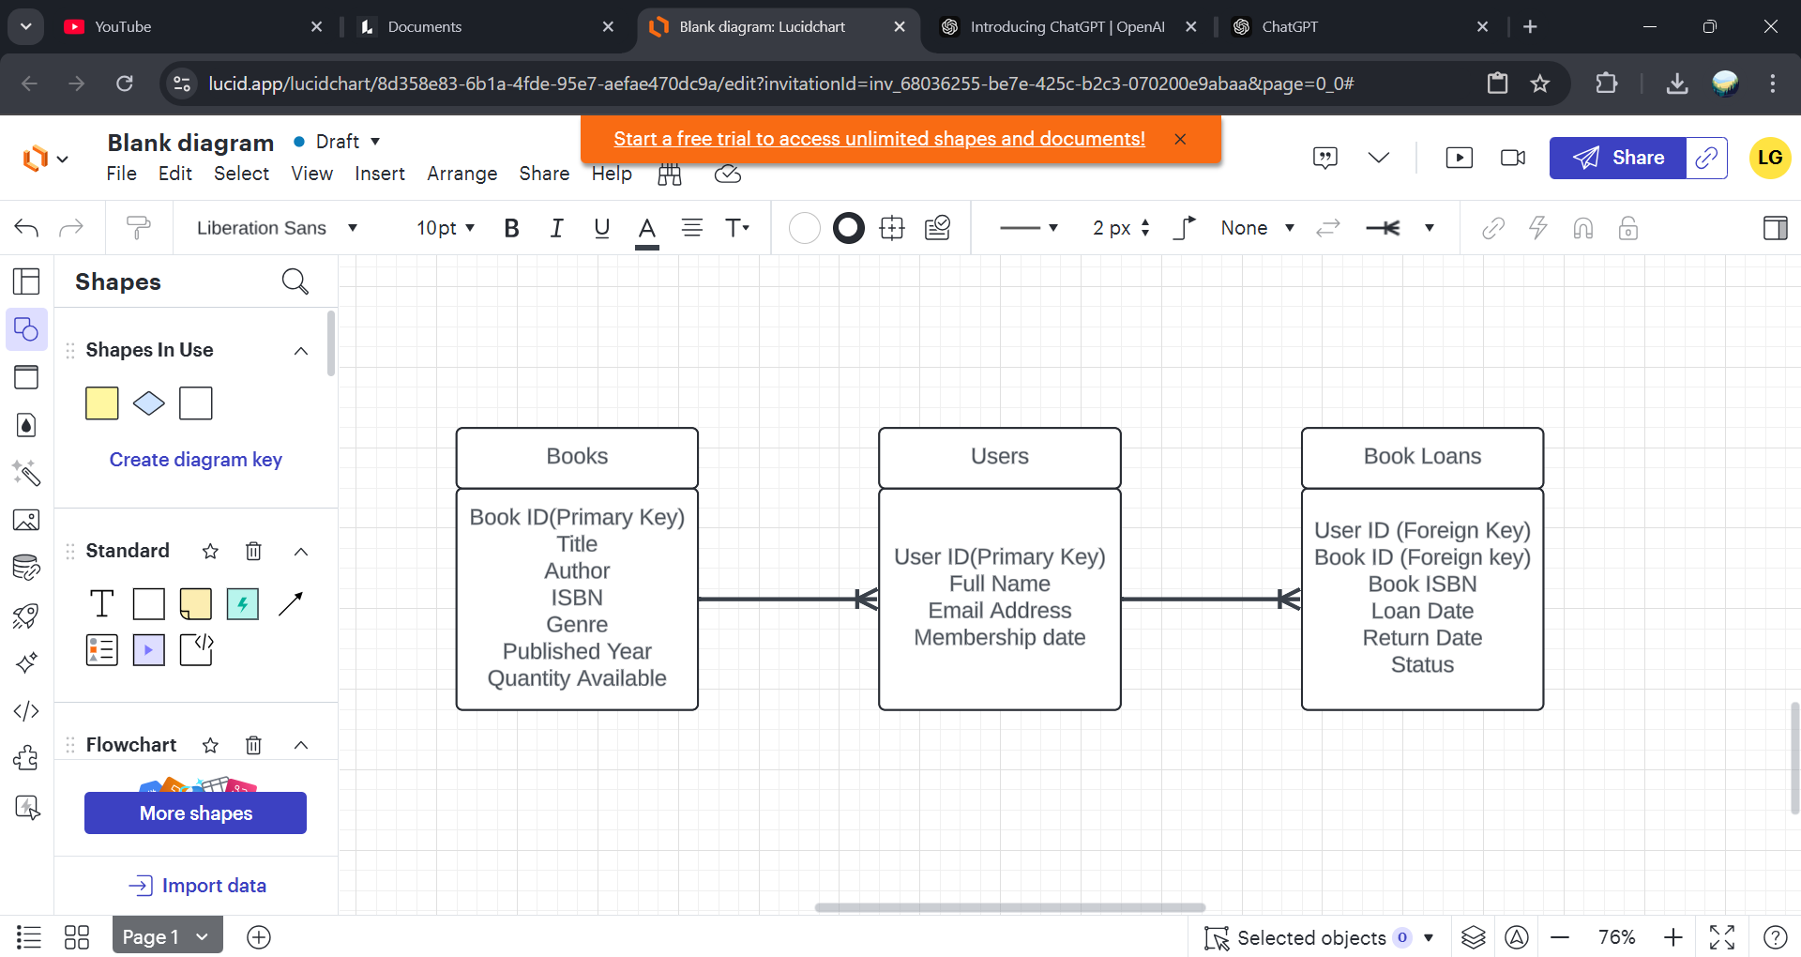**Conceptual Des**
2. **TABLES**

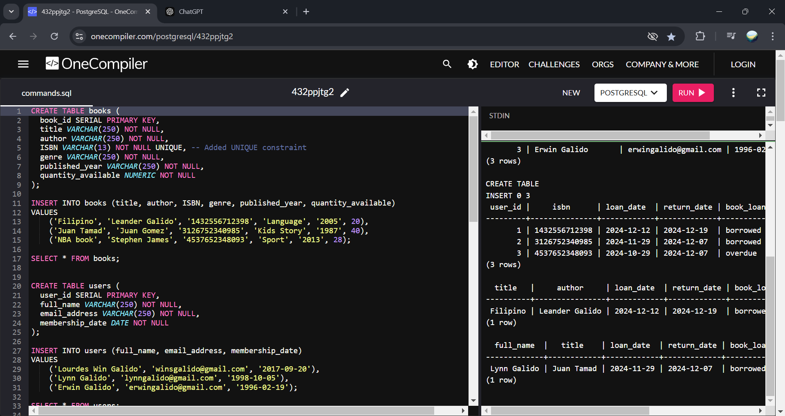

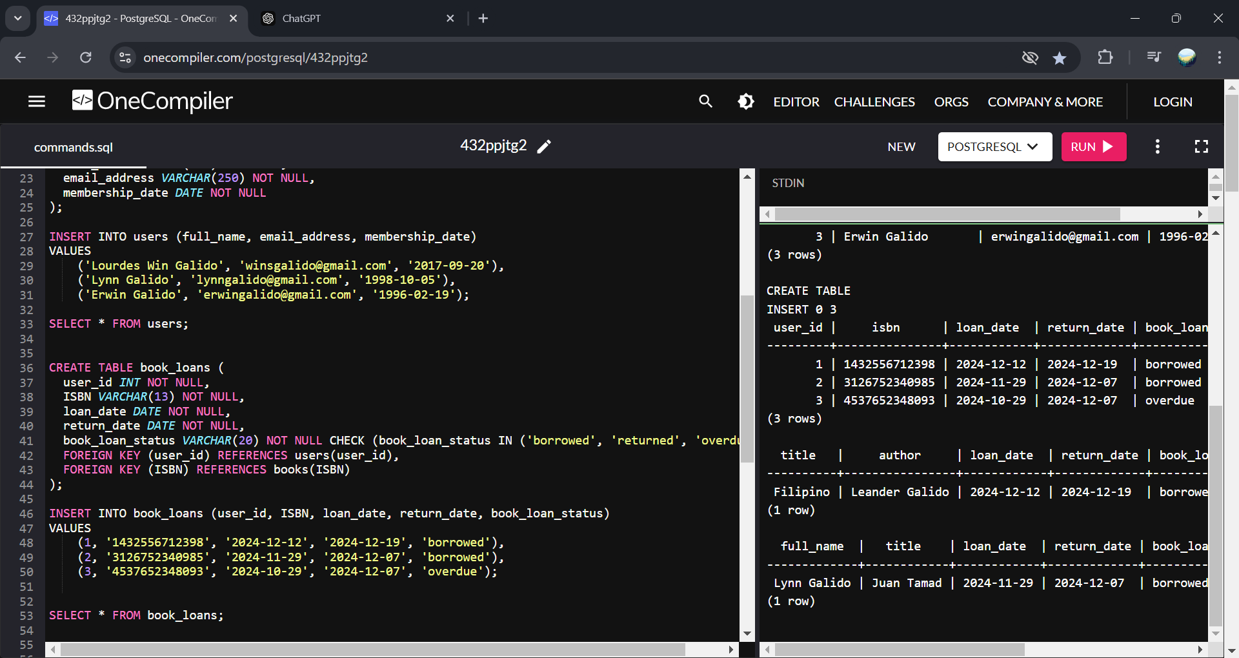

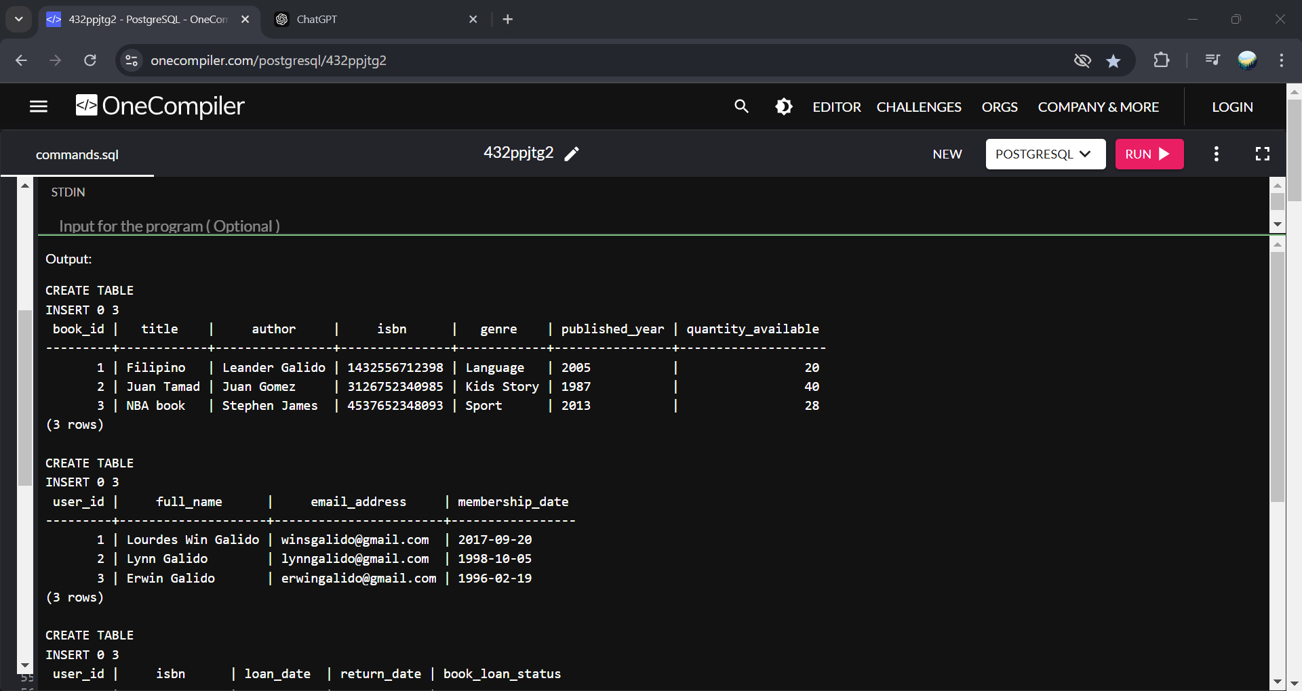

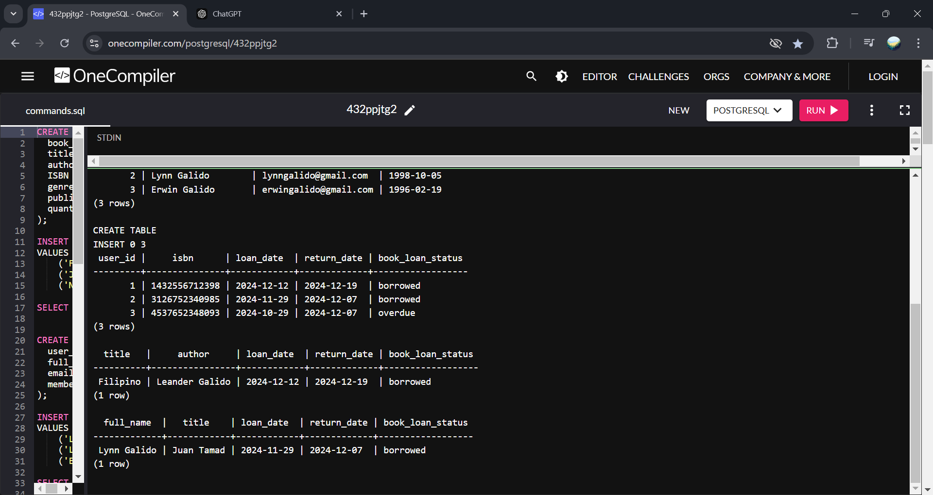

1. **SQL Queries**

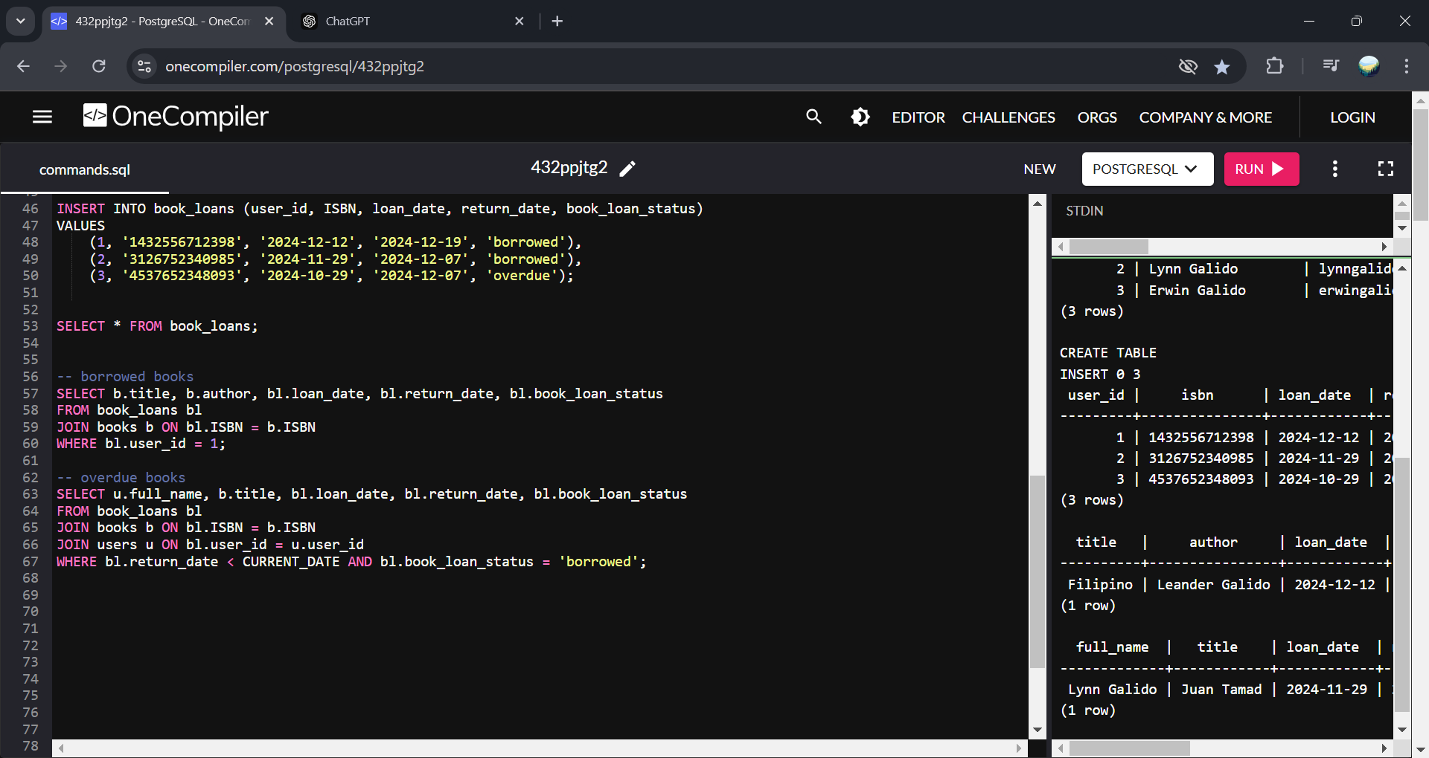

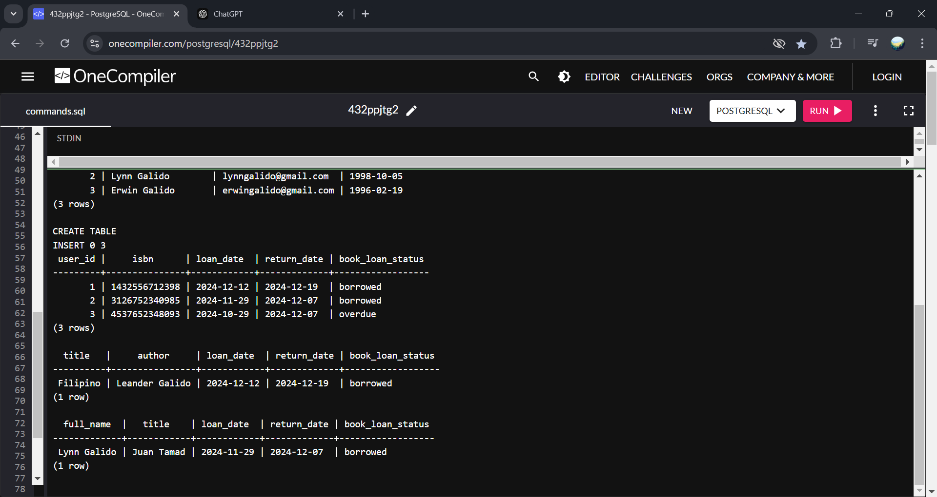

1. **Data Integrity and Optimization**

* **If the quantity of book is less than the quantity that user want to borrow, I will just put a function that displays a modal that the book quantity is not enough.**

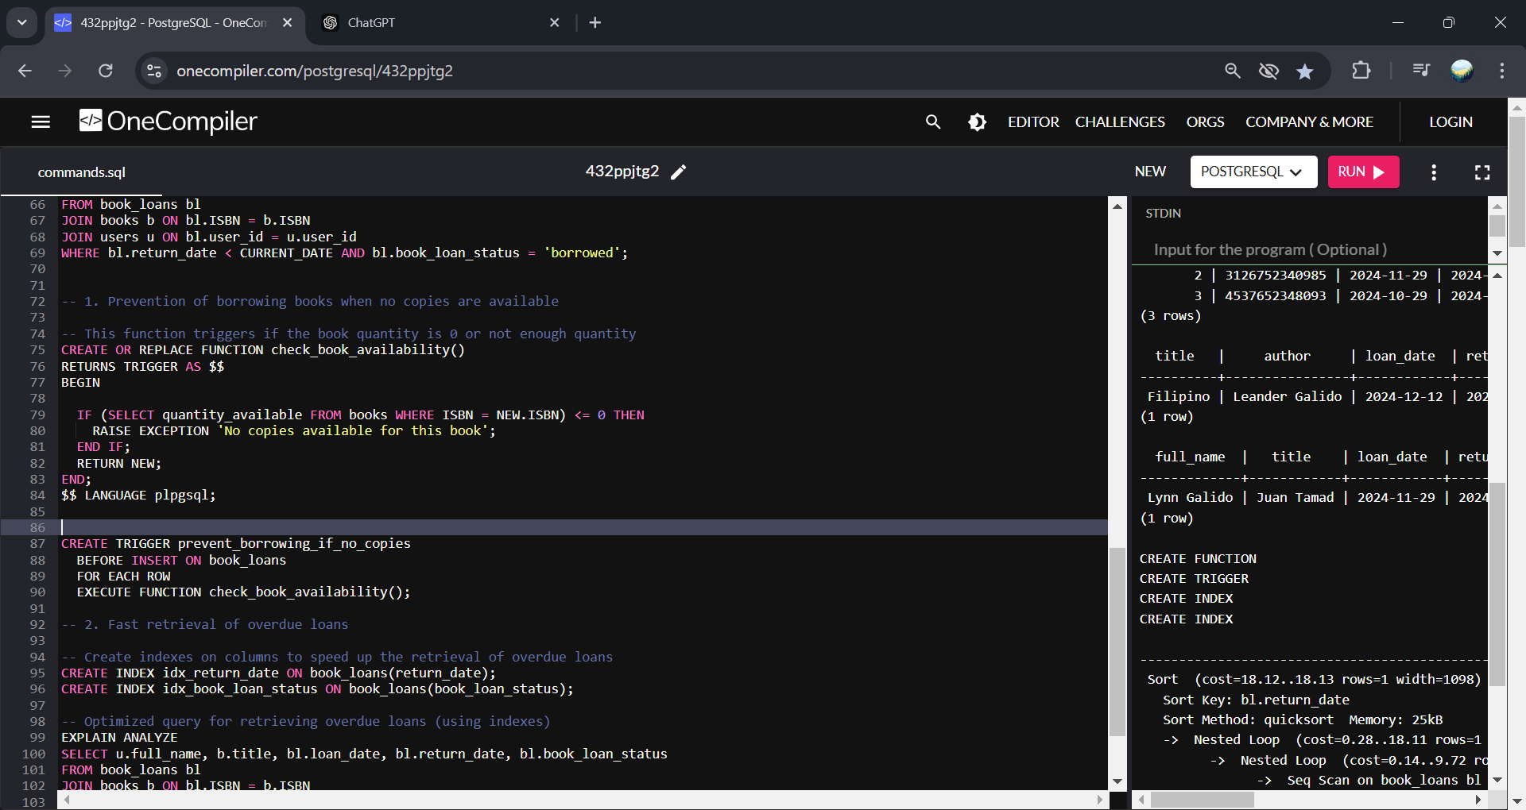

* **For fast data retrieval, indexes are first created on specific columns. When querying, the database uses these indexes to quickly locate relevant rows without scanning every element in the table, reducing the search time significantly.**

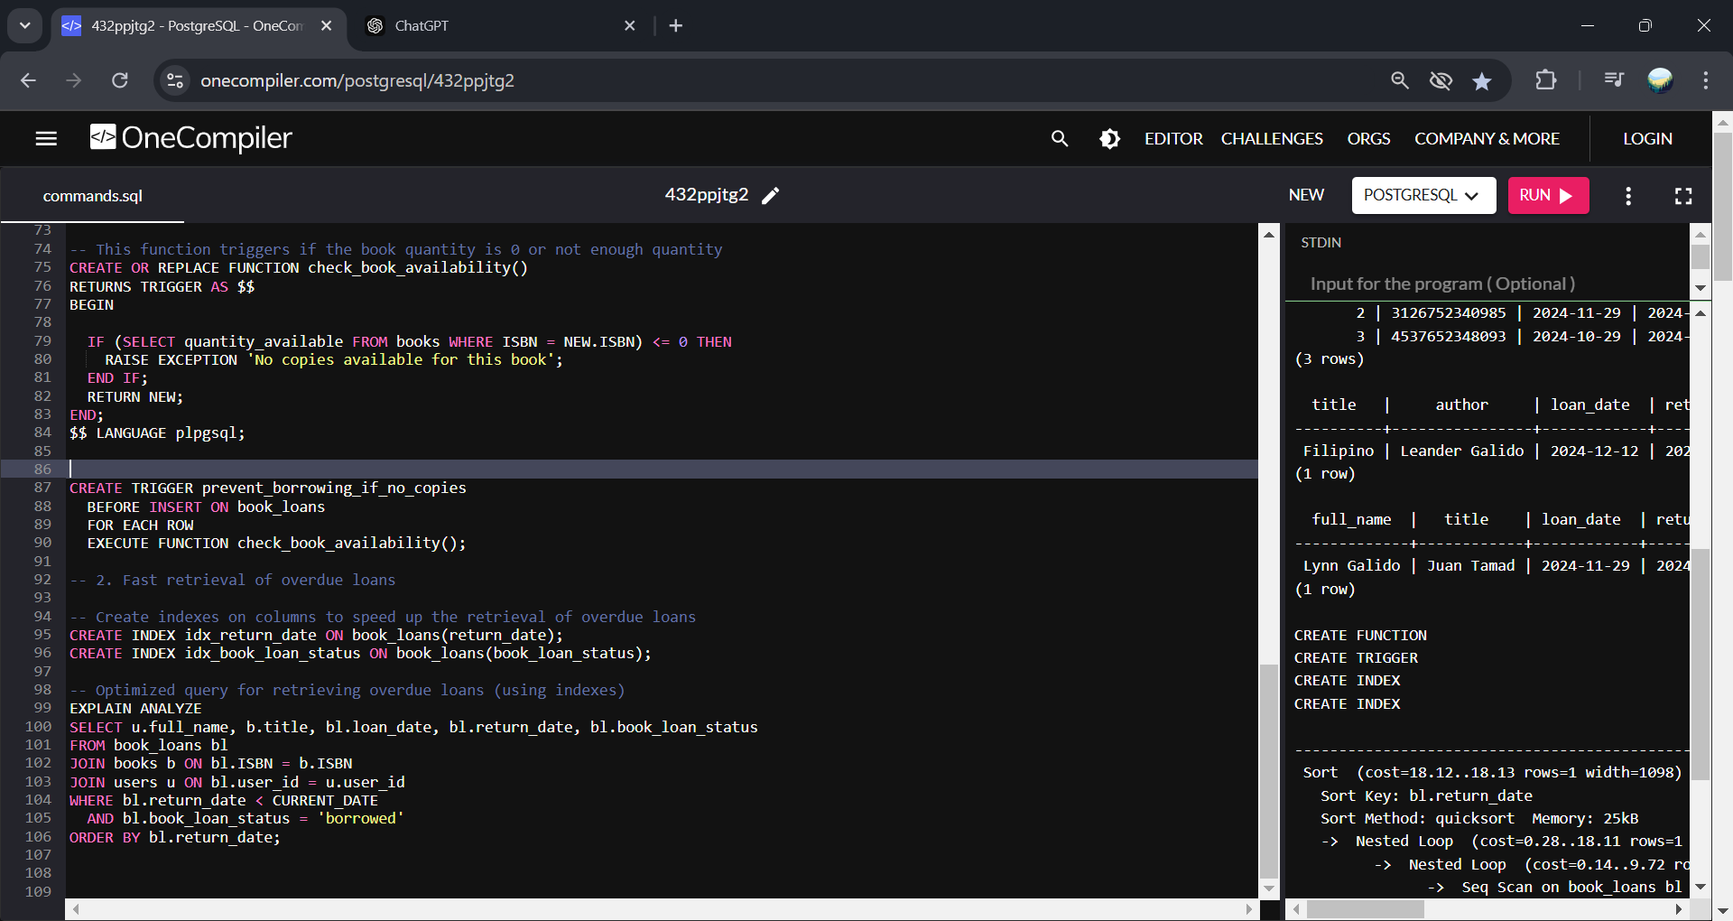

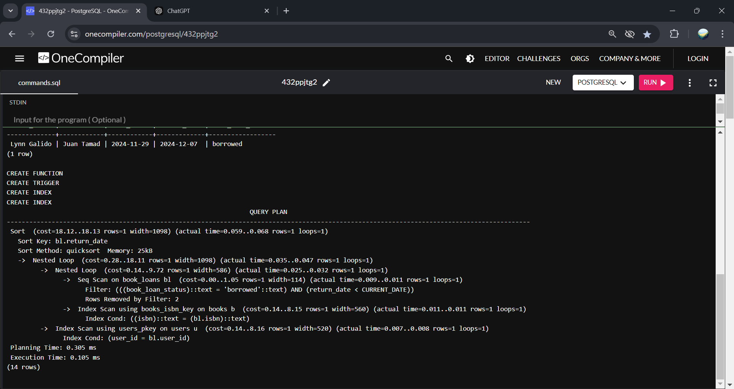

**Part 5. Reflection**

My experience in doing this activity is very useful it helps me to understand more on how to get/retrieve the data more faster than usual, it also improve my skills in using the postgresql because of the conditions applied into it like rules like you cannot borrow a book if it has zero quantity, at first it is somehow hard but with the help of searching and YouTube tutorials it help me finished this laboratory activity.